Emerging methods for early detection of forest fire MODEL BUILDING

SAVE THE MODEL

|  |  |
| --- | --- |
| Team ID | PNT2022TMID17141 |
| Project Name | Emerging methods for early detection of forest fire |

**SAVE THE MODEL**

Your model is to be saved for future purposes. This saved model also is integrated with an android application or web application in order to predict something.

**IMPORT LIBRARIES:**

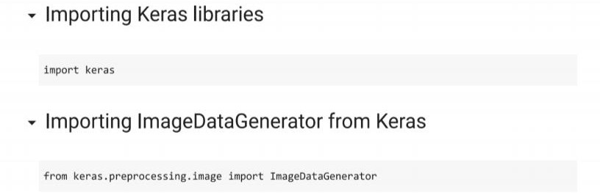

**IMPORT ImageDataGenerator FROM KERAS:**

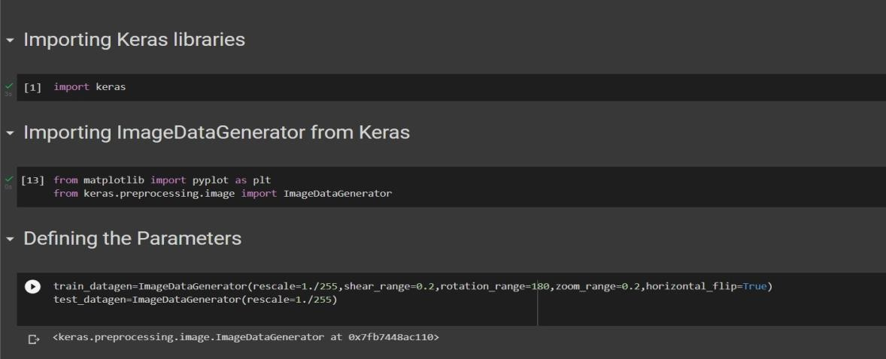

APPLYING ImageDataGenerator to train dataset:

ply**flow_from_directory ( )**methodfor Train folder.

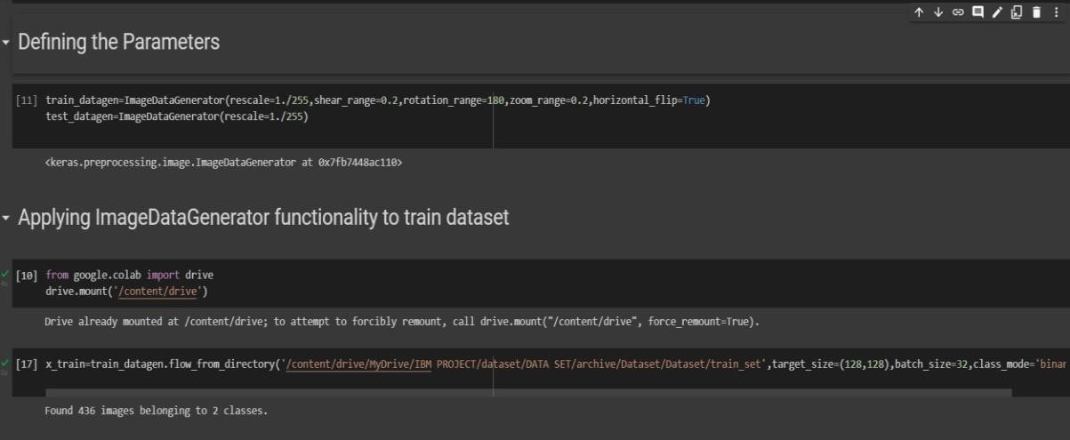

APPLYING ImageDataGenerator to test dataset:

Applying the **flow_from_directory ( )** methodfortest folder.

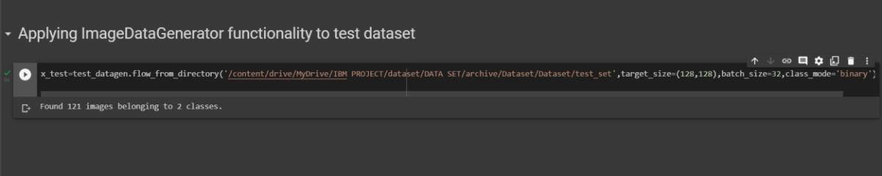

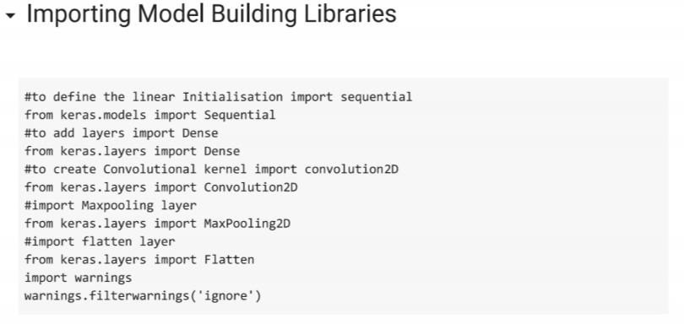IMPORTING MODEL BUILDING LIBRARIES:

**INITIALIZING THE MODEL:**

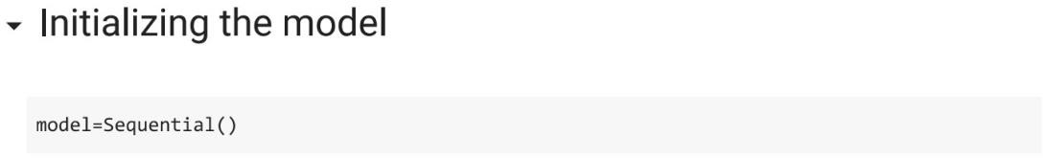

**ADDING CNN LAYERS:**

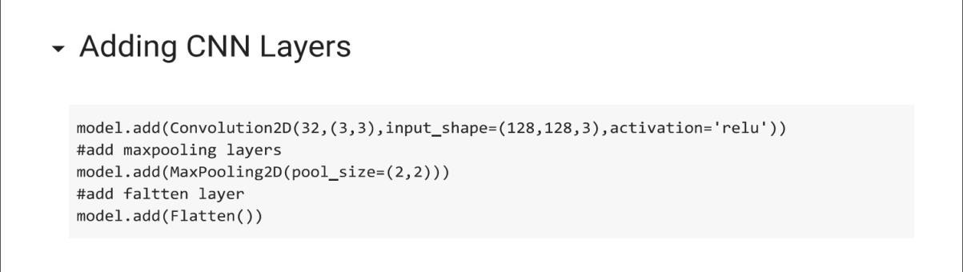

**ADDING DENSE LAYERS:**

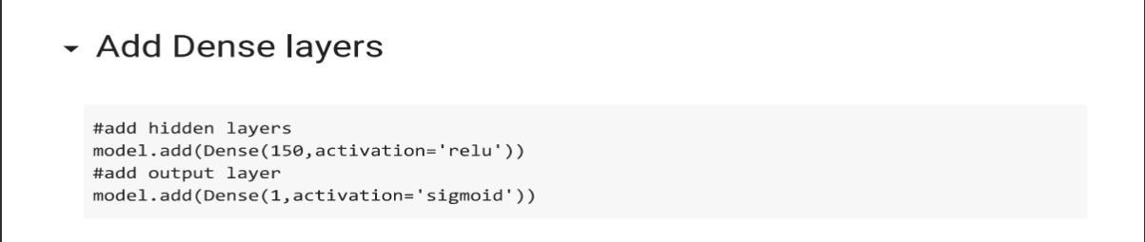

**CONFIGURING THE LEARNING PROCESS:**

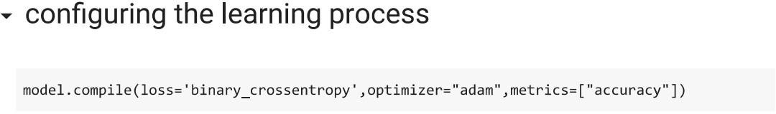

**TRAINING THE MODEL:**

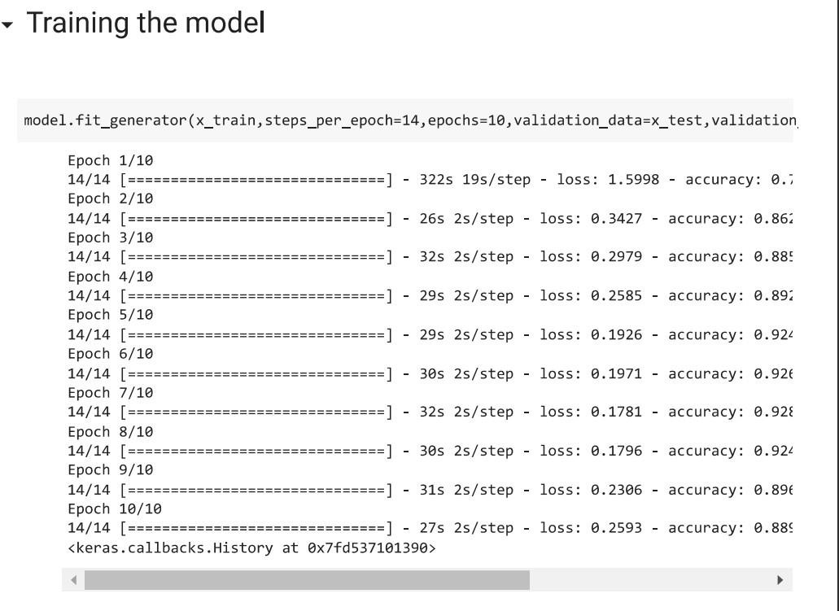

**SAVE THE MODEL:**

